# I have Deployed Nginx image by creating an AWS ECS cluster with an Fargate launch type and monitor the container matrices by using Cloud Watch.

First I create a Cluster named it **Gcluster** . In Gcluster I created 1 **service** in which 1 task is running

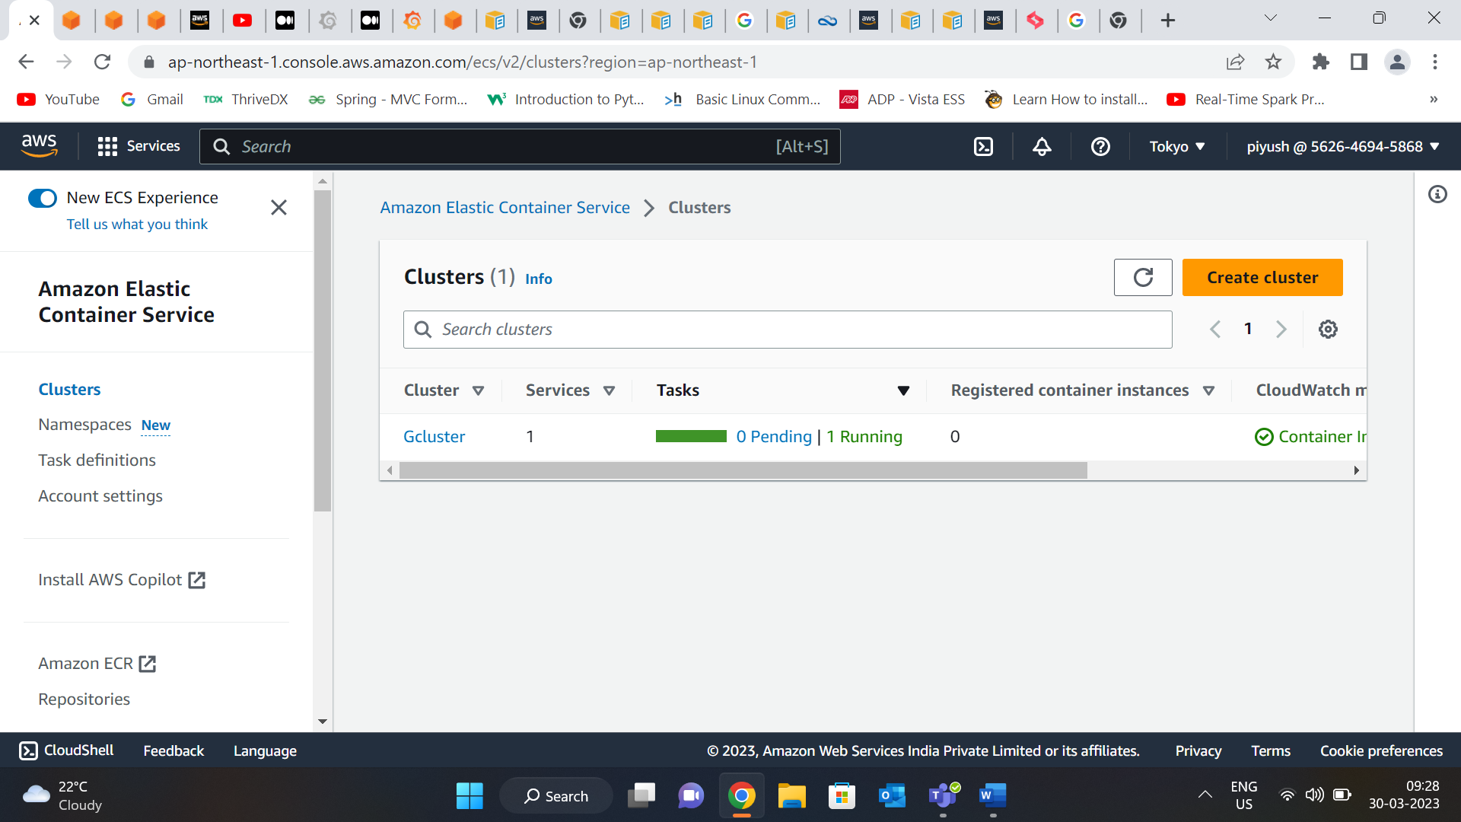

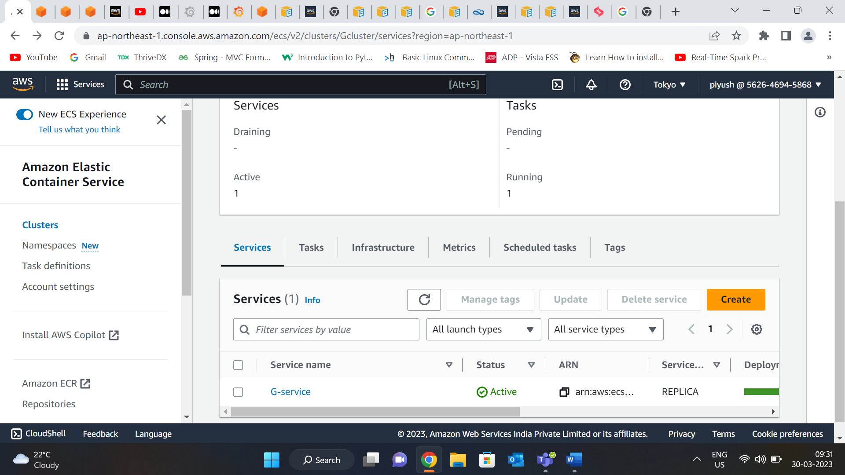

In **Task definition** there is one container called **Master.**

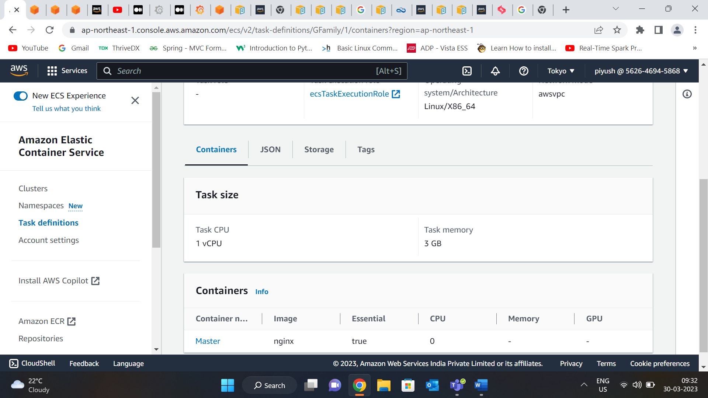

Then I moved to Cloud Watch , In container insight section I choose performance monitoring , then I select the cluster I which I want to do it .

Then , I got the **Container Performance** section in which you can see container called **Master** That I have created.

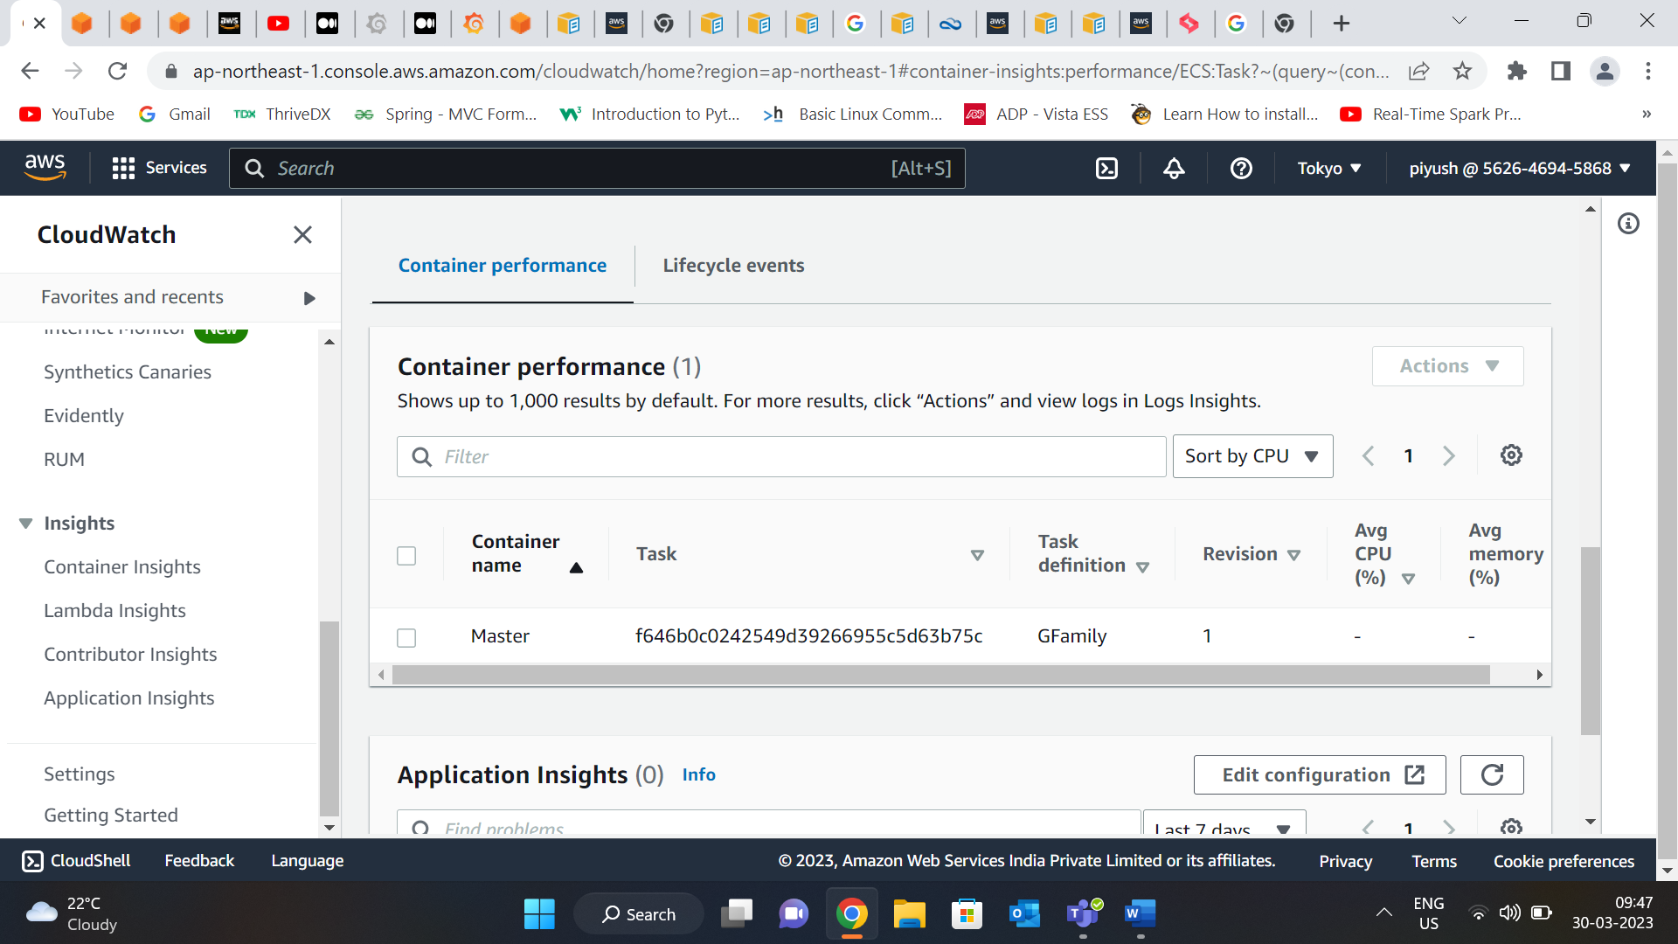

Then to check the performance of container we have to select the container after selecting the container name I go the **Action** and select **view performance logs.** This open Cloud Watch logs insights  for our ECS cluster.

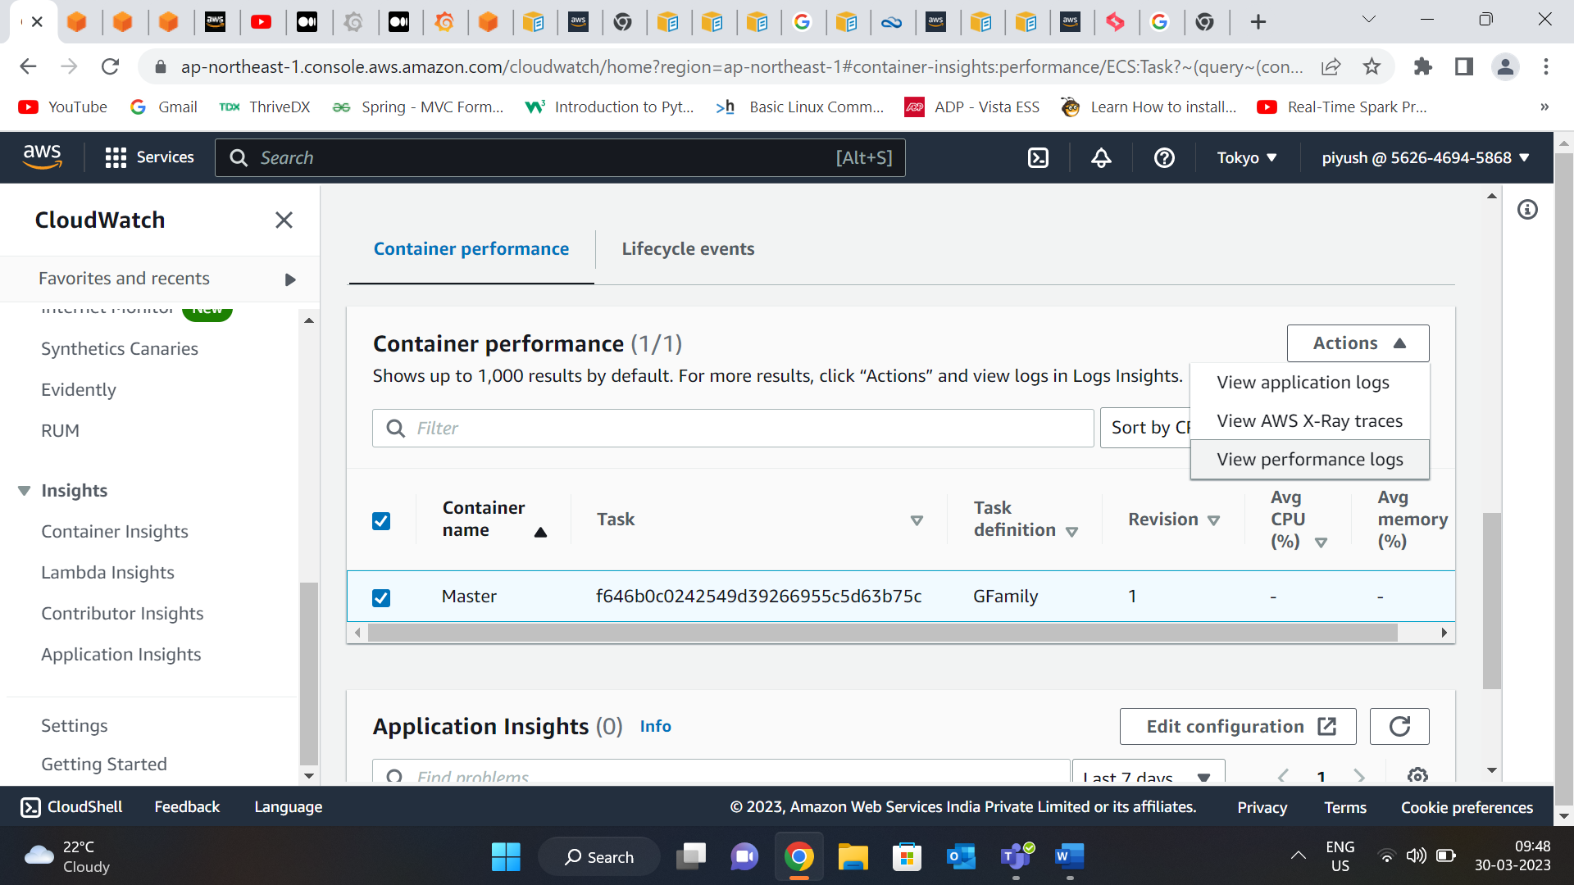

After that ae have to write the query to get the result we want . we can run our own custom queries.

After writing the query I get the results . This query will summarize the container performance data by the time period.

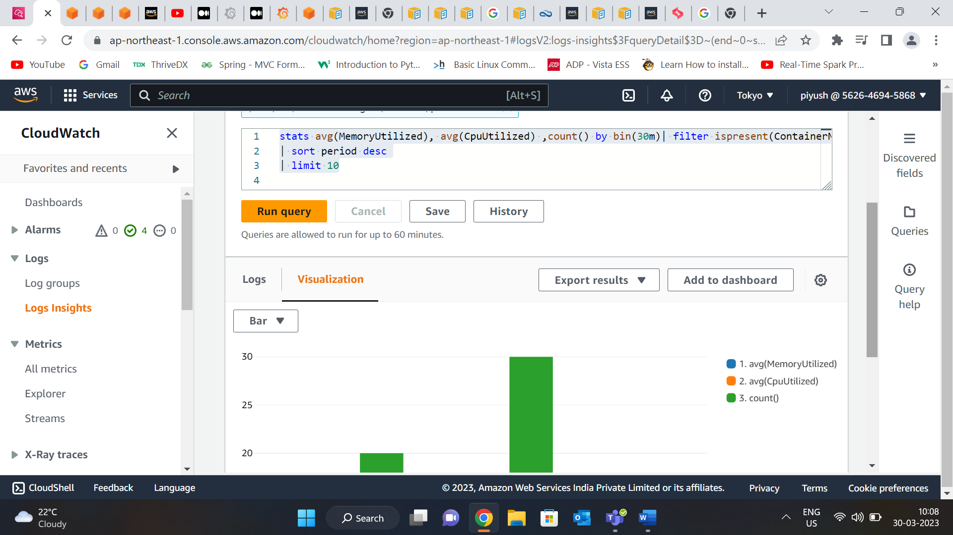

You can see the full query in the last slide of the document.

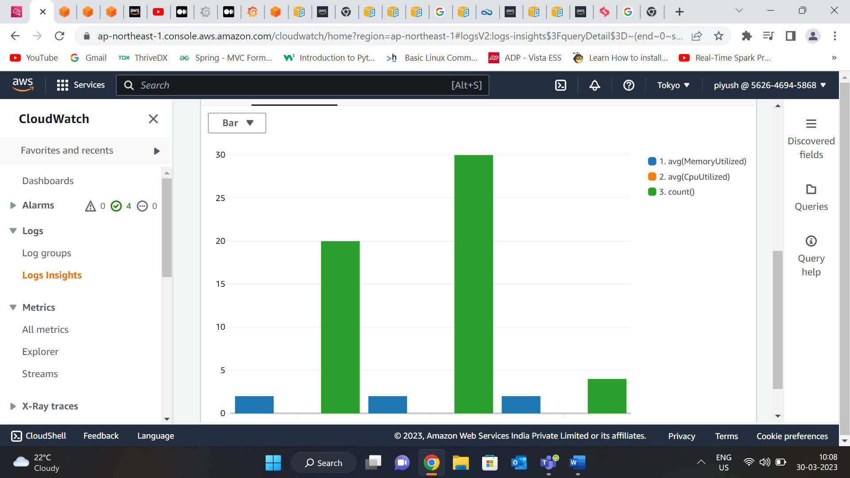

**Query :** 1.)

fields *@timestamp*, *@log*, *@logStream*, *@message*  |stats avg(MemoryUtilized), avg(CpuUtilized), count() by bin(50m) as period

| filter ispresent(ContainerName) and ContainerName like /Zero/ and Type = "Container"

| sort *@timestamp* desc

| limit 50

**Query 2.)**

stats avg(MemoryUtilized) by bin (30m) as period, TaskDefinitionFamily, TaskDefinitionRevision

| filter Type = "Task" | sort period desc, TaskDefinitionFamily | limit 10